Bug list



* Inner section of the form have a squeezed to the left and there is lot of space on the right

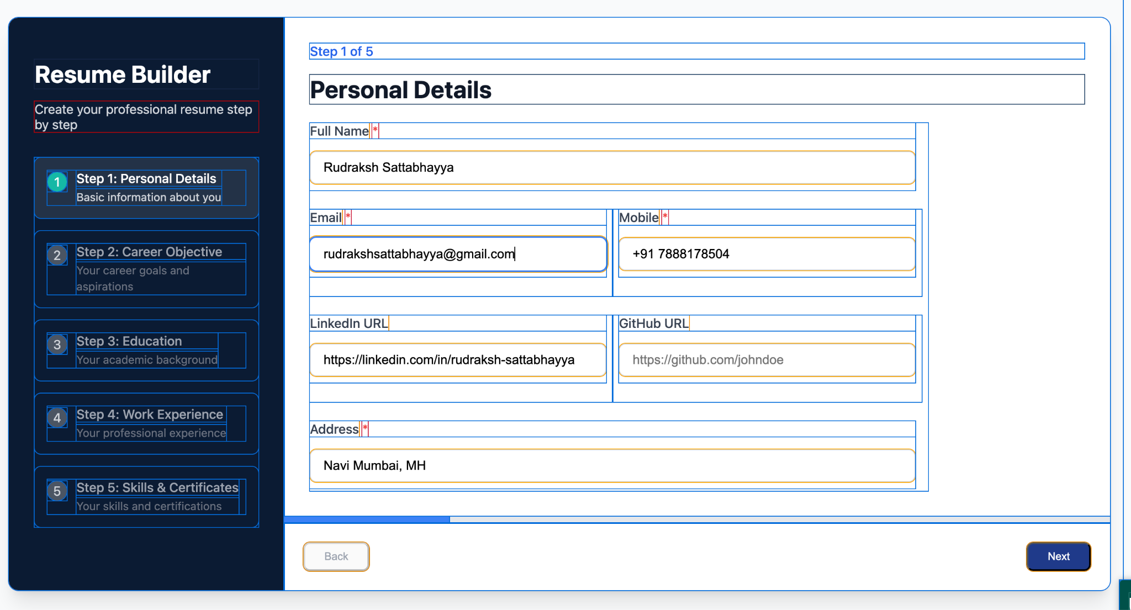

* This image i have used pesticide to understand the skeleton of the form
* In the first image also you can see blue boundary is cut off, i think it is bcoz the section which holds all the fields have no padding from left. You can try adding a little padding so it wont cut off.

 => Now

 => button should look like this basically no boundary

In the calendar component =>  
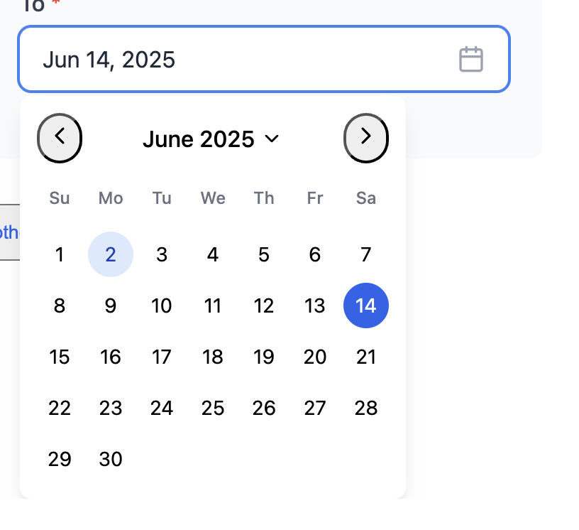

Next and prev button styles are messed up  
  
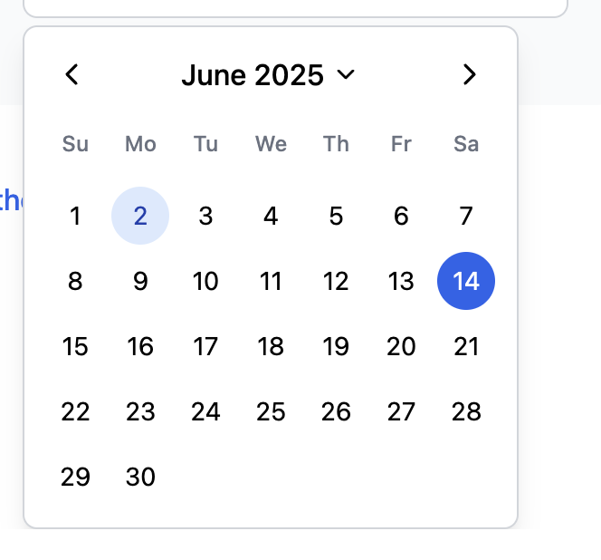 => it should look like this

All the add points or section button have style like this  
  
  
  
But should look like this  
  
  
Delete button also have some issues  
 => currently look like this  
  
But it should look like this  
 (mixed in background)  
  
  
Sometimes when hitting next next  
  
 =>in side bar it doesnt show 2nd step to be completed but it is completed